Professional Development: Introduction on Templates
Speaker: Mrs. Debora Liberi, CEEMS District Coordinator
Date: 06/21/2016
Time: 1:00 pm – 2:30 pm
Venue: University of Cincinnati, Zimmer Hall, Room 414
Prepared by:
Matthew Brunner, Saints Peter and Paul School, California, Kentucky
RET Project #3: Enhancing Decision Making Emulating Human Reasoning

This session was given by Mrs. Debora Liberi, CEEMS District Coordinator on Tuesday, June 21, 2016 in Zimmer Hall, room 414.

Debbie Liberi currently serves as the District Coordinator for the CEEMS grant at UC and as Coordinator for the RET Program. She earned BA in Biology at Wittenberg University and a Masters in Secondary Educations from UC, as well as, a Masters in Library and Information Science from Kent State University. She was a middle school science teacher and high school librarian for 35 years with CPS. From 2000-2010, Debbie was a National Board Certified Teacher in Early Adolescence Science. She also served as a lead teacher in various mentoring roles for CPS. In addition, Debbie has served as an adjunct faculty in the Teachers College at UC and at Xavier University.

Students were asked to give a thumbs up or down if they were comfortable using units. Most thumbs were down or sideways. Students worked on a pre-quiz on pencil and paper. The Templates are the structures used to build the Unit based on CBL. The Templates for the Unit and Activities are available on the Wiki and in the binders. Students were given hand-outs which described templates and how they are used with Challenge Based Learning. Students were asked to read and highlight anything that they felt was confusing or needed clarification.

Figure 1: Highlighting Questions Figure 2: Mrs. Liberi Showing the Road Map
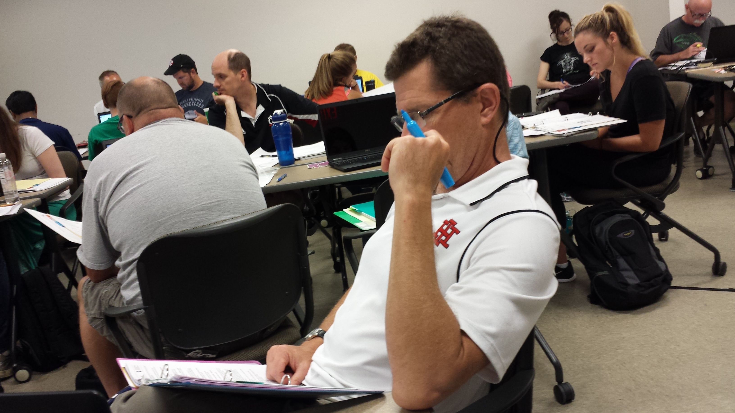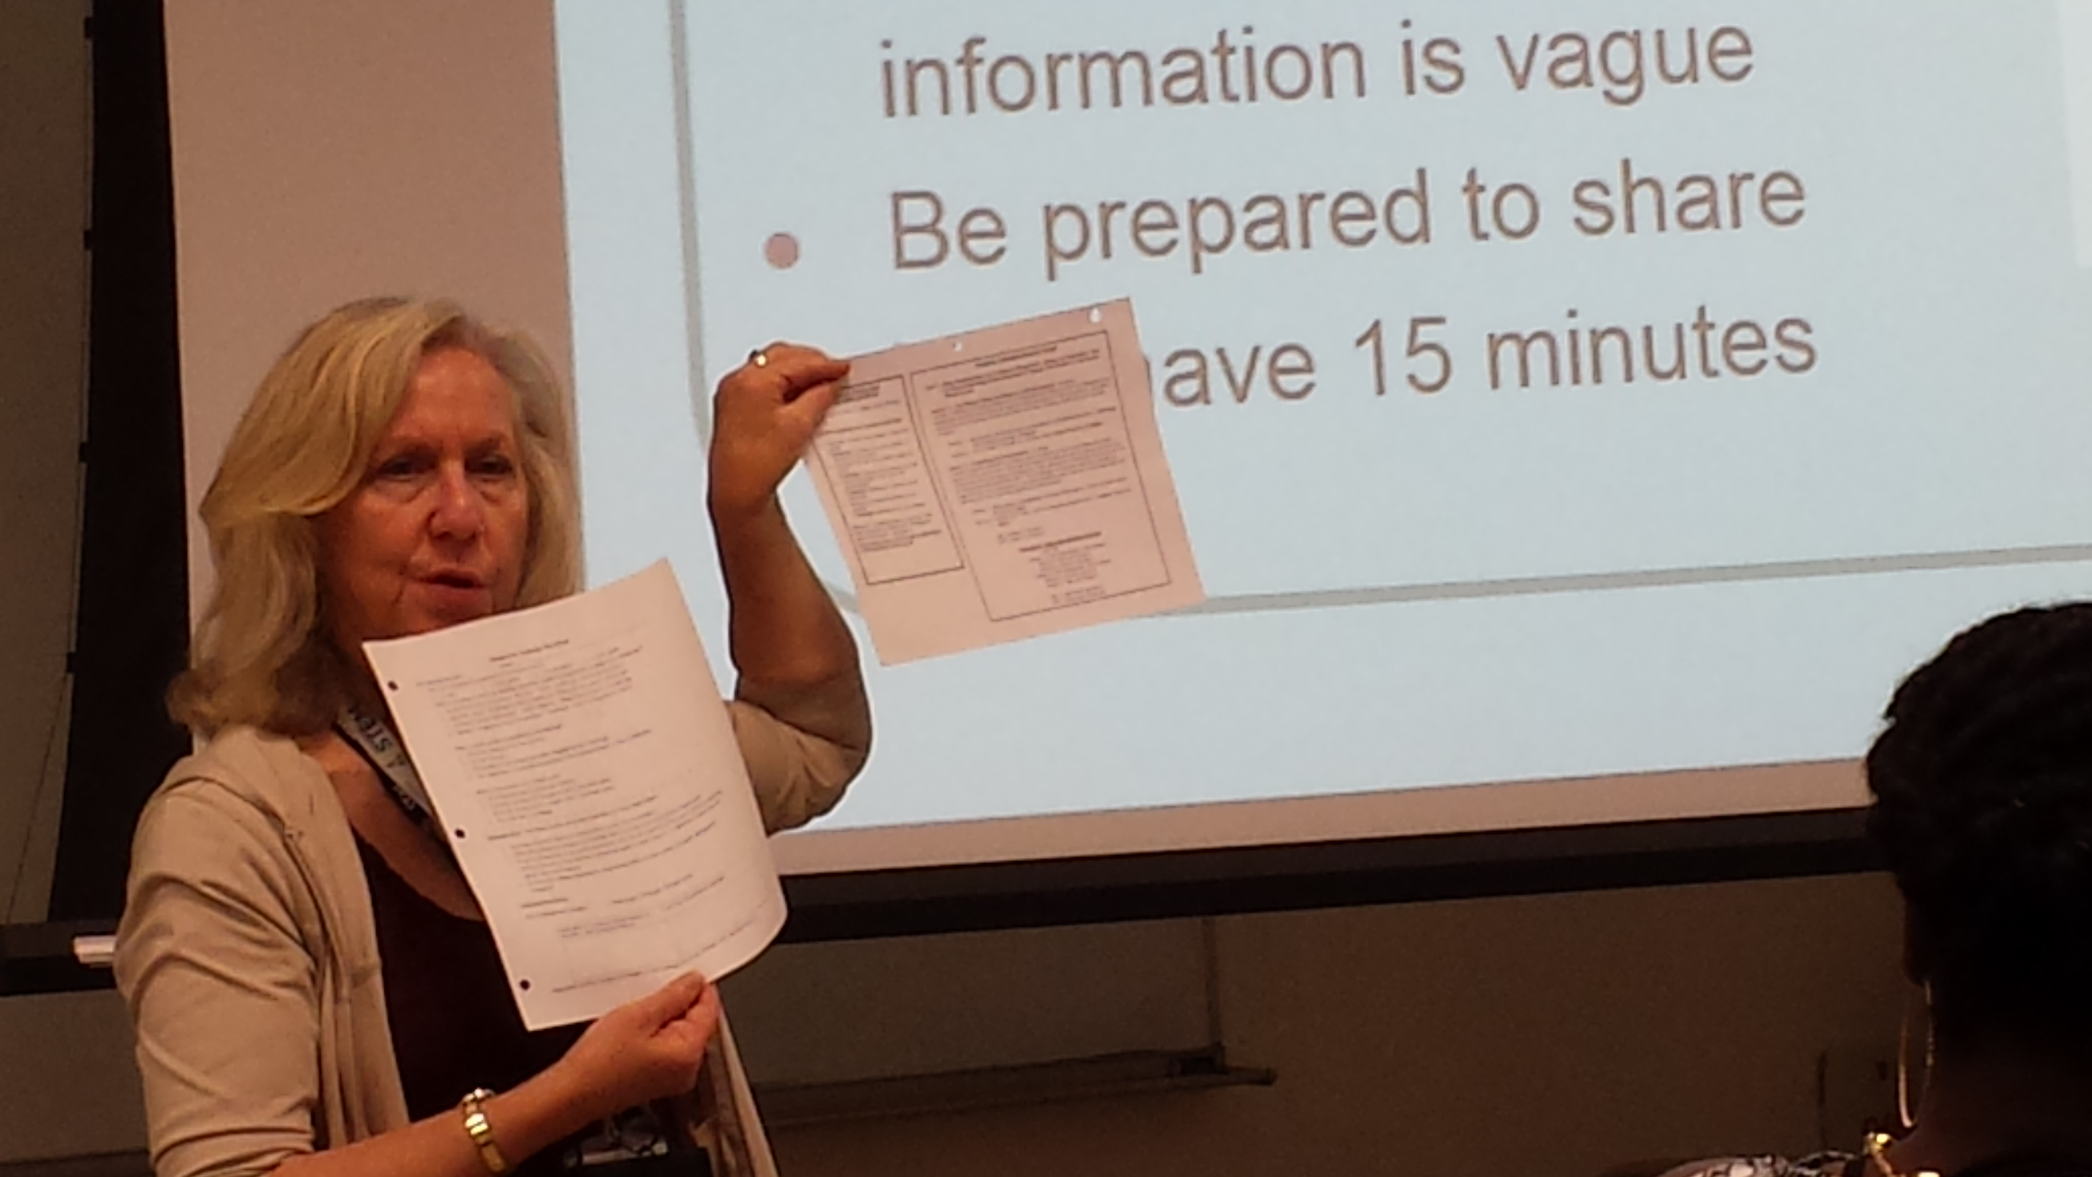

Mrs. Liberi took questions about anything that was highlighted. After all questions were answered she showed students the road map for the unit. Mrs. Liberi also shared was a glossary and sample lesson format which supports completion of the templates. The unit for challenge based learning consists of two lessons, each lesson has two activities. The length of the lessons is not set in stone, it can be several days or one day.

There is a hierarchy in the unit template. Start with the unit template, because that is where everything else flows. The unit template for CEEMS is a unit that involves a challenge; the unit is centered on the challenge. Students will be assessed while using the EDP cycle. It won’t look the same as the rest of your unit. A lesson can last several days and be over several concepts. Activities are standalone entities and can be used with or without the challenge.

Challenge based learning (CBL) and the Engineering Design Process (EDP) hold the students attention and keep them accountable. All CBL and EDP units must be based on the content standards. Mrs. Liberi asked students to think of hooks for their units. Having guest speakers, dressing up, playing games, demonstrations and videos were mentioned by students.

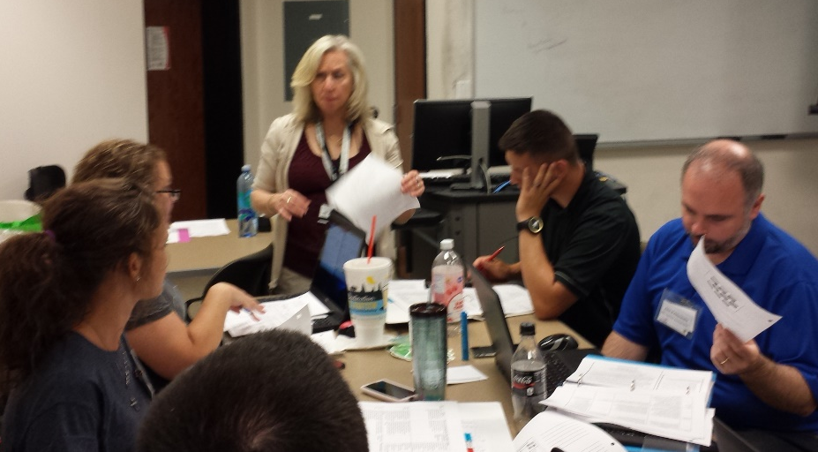
FIGURE 3: MRS. LIBERI DISCUSSING ASSESSMENT IDEAS IN CLASS

The question was asked: What kinds of formative and summative assessments are embedded in the EDP process? Students discussed at their some assessments that had been considered. Some of the ideas from the students were to use a flow chart and have students take a known substance through it, as a control, to see if the control arrives at the correct conclusion. Another idea was to test samples of green verses non-green products, then use acetone as a control. Use their process to create an advertisement that had a rubric. Take a known substance, bring it through the flow chart. Do this with everyone’s flow chart to see how it comes out. Test things to see if they will pass thorough the flow chart. Give students samples of green verses non-green products to see if they come up with the testing. Maybe there is a step in which they must imbed everything in the flow chart.

Guiding questions were discussed. Students were asked to name some guiding questions. Guiding questions are very specific questions about what learning needs to take place. Guiding questions are more related to how they will understand the challenge. These are the questions that must be answered before the challenge begins and they address what they need to know in order to do the challenge. Each challenge and activity will have its own set of questions that pertain to the information being taught.
Some examples include: Challenge: The difference between a green product and a non-green product. Guiding Question: How do you measure pH, difference between acid and a base?

Figure 4: Online assessment discussion
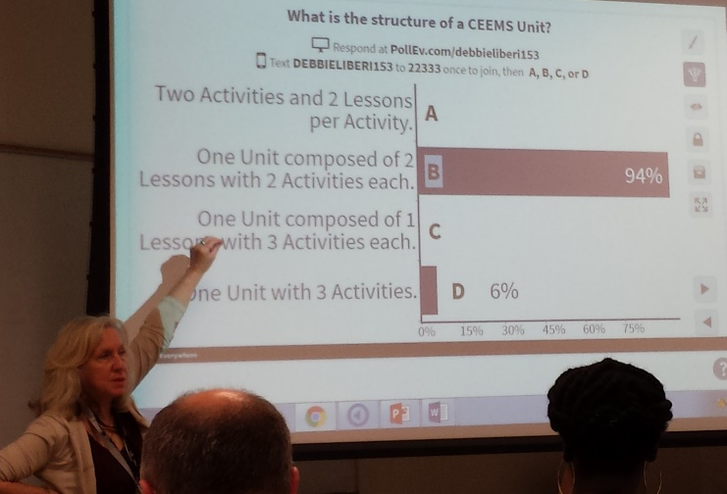

What kinds of formative and summative assessments are used? Students were asked to discuss at their table; some assessments that you had considered. Flow chart assessments are used to determine where you should start with your assessment. Use their process to create an advertisement that has a rubric. Take a known substance, bring it through the flow chart. Do this with everyone’s flow chart to see how it comes out. Test things to see if they will pass through the flow chart. For example, give students samples of green verses non-green products to see if they come up with the testing. Maybe there is a step in which they must imbed everything in the flow chart.

At the end of the session, students took an online poll, using PollEverything, as a post assessment. Each question was discussed before being dismissed.

